BEST TOWNS 2013: CARBONDALE, COLORADO

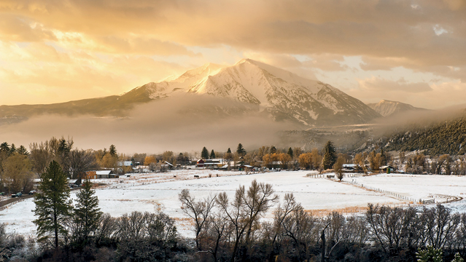
Photo: Seth Andersen
Population: 6,489
Median Household Income: $62,162
Median Home Price: $497,200
Unemployment (countywide): 8 percent
Votes: 1,267
Carbondale is only a 30-mile bike ride from Aspen, yet it still has weekly summer rodeos and cattle drives through town. In other words: it hasn’t become another Colorado boomtown—yet.
Located 6,200 feet high on Colorado’s western slope, the town is at the confluence of the prime trout waters of the Roaring Fork and Crystal Rivers.
“We live in town, and my husband can walk to the river,” says Erica Sparhawk, who works for Clean Energy Economy for the Region, a local nonprofit. “He pretty much thought he’d died and gone to heaven.” Many locals work in nearby ski towns like Aspen, although Carbondale does have a thriving green-energy economy, thanks to businesses like Sol Energy, Garfield Clean Energy, and Sunsense. Of course, with world-class biking, fly-fishing, rock-climbing, kayaking, and running at Carbondale’s doorstep, it’s a wonder anyone works at all.
Food and Nightlife: Carbondale is a small town with big-city cuisine. “Hands down, it has the best restaurants downvalley,” says reader Sunny Kay Harrison. Locals fill up at restaurants like the Village Smithy, Tortilleria La Roca, and chef Mark Fischer’s hot new restaurant Town (pork belly! Carbondale-raised steaks!). Each Wednesday during the summer, the farmers’ market fills the town with fresh peaches, locally-raised meats, and, of course, potatoes. (Carbondale has a Potato Day festival.)
Access: You hardly need a tank of gas to reach the surrounding wilderness. The 181,000-acre Maroon Bells–Snowmass Wilderness and its 100 miles of trails are just an hour from town. In winter there’s skiing at Aspen and Snowmass and at the cheaper Sunlight Resort in Glenwood Springs.
Biking: “On every trail or road ride, you see friends along the way,” says Tom Stevens. “And the local watering hole has so many bikes parked outside, you can barely get in.” The 44-mile paved Rio Grande Trail runs from Aspen to Glenwood Springs, with a spur up the Crystal River. Nearby road-biking opportunities include quad-burning, 12,000-foot Independence Pass, while Prince Creek and Red Hill offer prime mountain biking just outside town.

