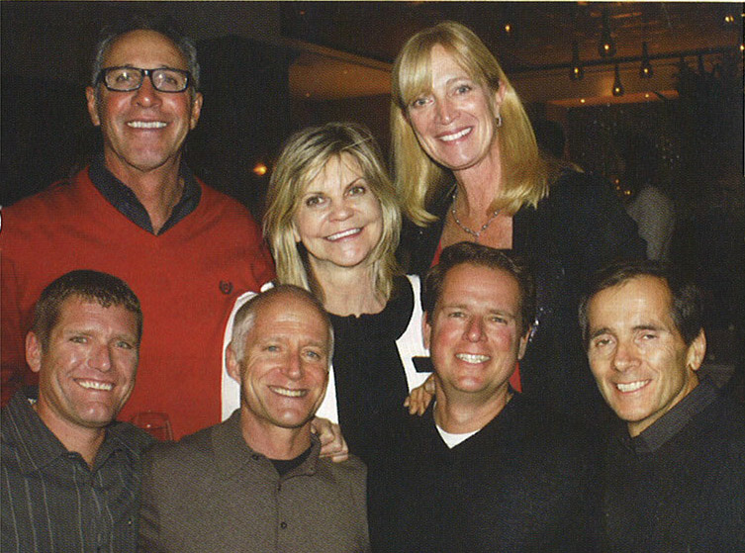
Aspen Board of Realtors
Trecento Quindici Decano restaurant in the St. Regis hosted
the annual Aspen Board of Realtors holiday celebration.
Bottom right to left: Danny Becker, Gary Kelley, Brian Leasure and Darryl Grosjean
Second Row Tony Coia, Karen Toth and Brenda Wild

Aspen Sojourner Magazine
Midwinter/Spring 2014

